
Private bushfire shelters in Victoria
A guide for siting, landscaping and use

On hot, dry, windy days, especially on Catastrophic Fire Danger Rating days, leaving the area early is always the safest option. It is best to leave before there is any chance of fire in your area, including along your travel path.

CFA recognises that people may decide to install a private bushfire shelter on their property for their family’s safety or as part of their decision to build a new home in a bushfire risk area. This guide has been developed for those who are considering installing a private bushfire shelter, to help you with planning and preparation around this shelter option for improved bushfire safety.
Using a private bushfire shelter is not without risk; there is no guarantee it will save your life. It is not an alternative to leaving early and it should never be a stand-alone solution. It needs to be part of an overall bushfire plan. A private bushfire shelter may form part of a household’s backup plan. For example, when it is too late to safely leave the area or it is unlikely that you will be able to safely protect your home from a bushfire.
A private bushfire shelter (commonly referred to as a bushfire bunker) that meets the Building Regulations 2018 (Regulations) may provide a temporary place of refuge from the life-threatening effects of a bushfire. However, the inappropriate siting, landscaping, or use of a private bushfire shelter can lead to serious injury or death.
If you are considering a private bushfire shelter, you must ensure that:
- the shelter is built to meet the Regulations and performance requirements referenced in this guide
- a building permit is obtained prior to construction
- the shelter is sited (installation location) appropriately
- the surrounding space is managed to provide appropriate separation distance from fire hazards to improve safety when entering and exiting the shelter, before and after the passage of a fire front
- the shelter is properly equipped and maintained to ensure it is in optimal condition
- you are physically and mentally prepared to use a shelter during a fire event.
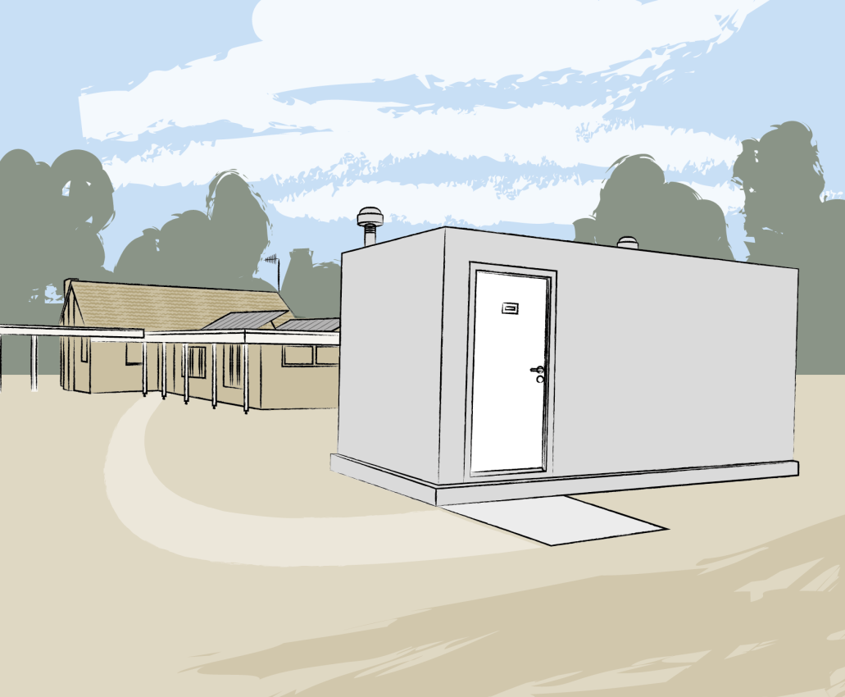
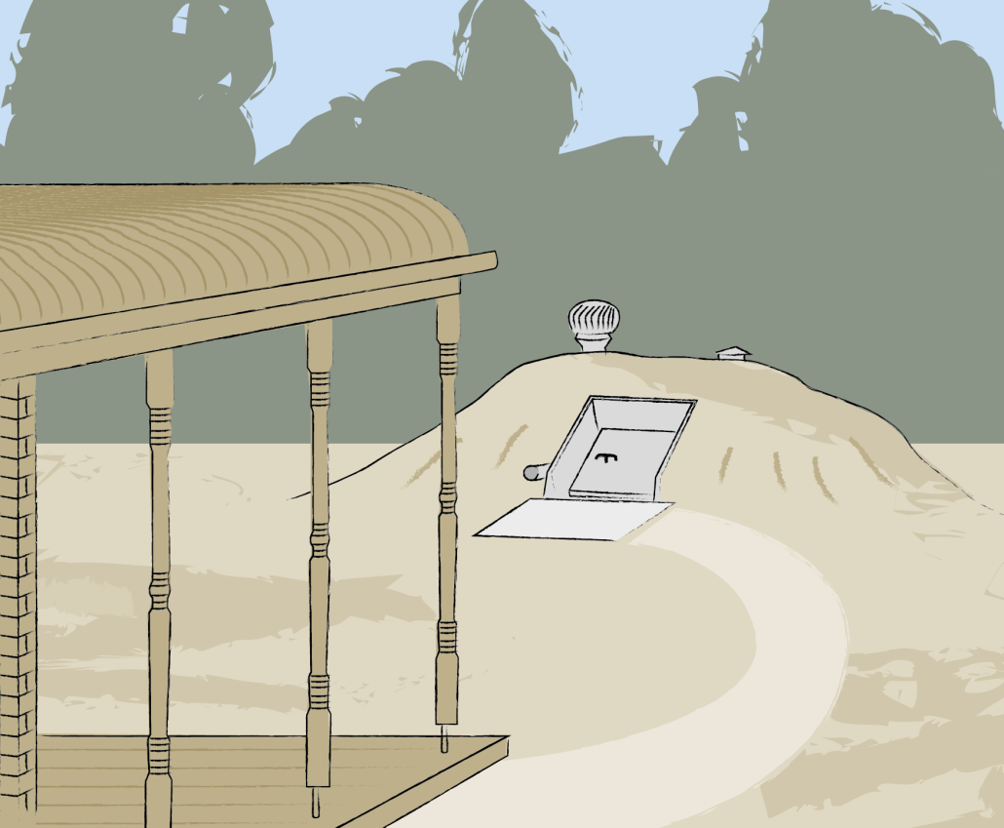

Use this as a general guide for siting, landscaping and using a private bushfire shelter.
Once you have chosen an accredited shelter product, refer to the shelter provider’s product manual for specific siting requirements. If you choose to construct a non-accredited shelter you must seek professional advice from a registered fire safety engineer and source approval of the design according to the Regulations.
Read CFA’s Fire Ready Kit to help you understand your risk and prepare your household’s bushfire plan.

© State of Victoria (Country Fire Authority) 2022
This work, Private Bushfire Shelters in Victoria A guide for siting, landscape and use, is licensed under a Creative Commons Attribution 4.0 licence, creativecommons.org/licenses/by/4.0/ . You are free to re-use the work under that licence, on the condition that you credit the State of Victoria (Country Fire Authority) as author, indicate if changes were made and comply with the other licence terms. The licence does not apply to any branding, including the Country Fire Authority (CFA).

CFA makes this information available on the understanding that you take reasonable care when using it. If you have any uncertainty about the application of the information to your particular circumstances, you should obtain further professional advice.
CFA does not accept responsibility for how you apply or rely on the information in this publication.

Acknowledgement
CFA acknowledges the contribution made by CSIRO to the information in this publication.
Victorian Building Regulations, performance standards and permit requirements you need to know before constructing a private bushfire shelter

In Victoria there are design, siting and construction regulations for private bushfire shelters:
- They must comply with the Victorian Building Regulations 2018 (Regulations) and the National Construction Code (NCC) performance requirements.
  - The Australian Building Codes Board (ABCB) Performance Standard for Private Bushfire Shelters provides guidance for shelter designers and builders to meet the NCC performance requirements. The Performance Standard can be viewed on the ABCB website abcb.gov.au.
    - The Performance Standard provides objectives around what needs to be considered and achieved when designing a shelter, but is not a guide for how to build one.
    - If planning to construct a non-accredited shelter, do not rely solely on information within the Performance Standard. You must seek professional advice from a registered building practitioner, such as a fire safety engineer or a structural engineer.
- You must obtain a building permit prior to construction as a part of the Regulations. Installation of a shelter without a valid building permit is illegal. Building permits can be obtained from your local council building department or from a private building surveyor.
- To comply with building permit requirements, the homeowner must either:
  - buy a shelter which has been accredited by the Building Regulations Advisory Committee (BRAC) as meeting the Regulations. Accredited products include both in-ground and above-ground shelters
  - apply to the Building Appeals Board (BAB) for a determination that the design of a non-accredited shelter complies with the Regulations, or
  - obtain a certificate of compliance from a registered fire safety engineer who did not design the shelter, to satisfy a building surveyor that the non-accredited shelter meets the Regulations.
See the Victorian Building Authority (VBA) website vba.vic.gov.au for a list of BRAC accredited products, information about the BAB process, and to find a registered fire safety engineer.
- In some instances, councils may also require a planning permit. It is important to check with your local council for permit requirements. Find your local council contact details at knowyourcouncil.vic.gov.au
- In bushfire risk areas, you may not need a permit to clear vegetation and trees from around your home. However, it is important to check with your local council. Different rules apply in different council areas and tough penalties can apply.
Warning:
- Products used as bushfire shelters that are not built to the Regulations and building permit requirements (eg shipping containers, storage units, etc.) can be potential death traps.
- A shelter made of fireproof materials is only one level of protection. Bushfire shelters built to meet the Regulations and performance requirements include other safety elements such as:
- constructed to withstand conditions that can be experienced during extreme bushfire events
- airtight when sealed (vents and door closed) to stop smoke entering and to maintain breathable air for a specified period of time
- designed so that the inside temperature can be kept at survivable levels for a specified period of time.
- The VBA warns Victorians against buying non-accredited private bushfire shelters or using storage units as shelter in the event of a bushfire. This includes models by companies that have not been approved by the BRAC. Bushfire shelters that are not accredited must be thoroughly assessed for compliance with the NCC as part of obtaining a building permit.
Note:
- CFA does not test or endorse private bushfire shelters as complying with the Regulations and NCC performance requirements.
- CFA recommends that you request a copy of the shelter certificate of compliance from the shelter designer or manufacturer. Either a certificate of accreditation from the BRAC, a determination from the BAB, or a certification of compliance from an independent fire safety engineer who did not design the shelter.
Key steps when siting and landscaping a private bushfire shelter

❶ Recognise the fire hazards
- A fire hazard is any fuel that may present a risk to you while entering or exiting a shelter.
There are two types of fuels – fine and heavy.
FINE FUELS such as leaves, twigs, unmaintained lawn, grassland (pastures, crops and areas of undisturbed natural grassland), loose bark and plant foliage can:
- ignite quickly and burn easily
- support large fast-moving flames, radiant heat and embers.

HEAVY FUELS such as trees, branches, logs, vehicles, farm machinery, fencing, garden furniture, outdoor spas, wood piles, timber retaining walls, garden mulch, and adjacent buildings (such as sheds, carports, houses) can:
- burn for many hours after the bushfire arrival
- provide a heat load that persists longer than a passing bushfire front.

❷ Distance to fine fuels
- Remove fine ground fuels from within your property boundary or to a minimum of 30 metres from your shelter and home. This will reduce the bushfire intensity and the likelihood of new fires starting near your home or shelter.
- Create a clear space, an area of low fuel surrounding your shelter using mown grass to less than 10cm in height or a non-combustible surface (eg clay, concrete, pebbles or gravel).
- Do not plant on or around your shelter. This will add fuel and threaten your safety when entering or exiting the shelter.
- No plant is completely fire resistant. Given the right conditions all plants will burn. Some are more flammable than others. The CFA ‘Landscaping for Bushfire: Garden Design and Plant Selection’ can be used to create new or modify existing gardens. Use the online ‘Plant Selection Key’ when choosing plants for areas beyond the clear space surrounding the shelter. By choosing plants with low flammability you can lower the chance of fires starting in the garden during an ember attack. It can also help reduce the effects of radiant heat.
- Consider what is growing under your trees. Fire might be able to spread easily from the ground into the tree tops.
  - Remove or trim shrubs so their branches are well away from tree branches and ground fuels.
  - Clear space between plants and trees.
  - Remove loose tree bark and remove lower tree branches to a distance of at least 2 metres above the ground.

❸ Distance to heavy fuels
- Accredited shelters will come with a product manual. It will have a set of separation distances for the shelter from heavy fuels and property boundaries. The minimum distance is usually greater than 6 metres.
- Trees, tree branches and building elements near a shelter can be extremely dangerous. They can fall and damage the shelter; block the door or pathway; bring fire risk (flames, heat) closer to your shelter; and raise your risks when exiting.
  - Buildings and the mature height of surrounding trees should be no less than 6 metres or 1.5 times their height away from the shelter, whichever is greater. For example, if a mature tree height is 8 metres, the shelter should be located at a minimum of 8 metres x 1.5 = 12 metres away.
- Before you decide to remove vegetation, particularly trees, you should contact your local council.
- The separation distance from the shelter to the heavy fuel is critical to improve safety when exiting the shelter.
- Find a site well away from all fuels, greater than the minimum recommendations where possible.
- Locate farm machinery and vehicles well away from the shelter as they too may become fuel in a bushfire.
- Do not use treated pine products (eg posts, sleepers or decking bearers) in garden design, or wood chip mulch within 10 metres of your shelter or house. These materials are quick to ignite, produce toxic ash and smoke, and are difficult to put out.
- Build landscaping features to provide barriers to wind, radiant heat and embers such as stone walls or non-combustible fences, earth mounds or cut-and-fill terracing. Use materials such as brick, earth, stone, and concrete.

❹ Distance to other hazards
- Store gas bottles and flammable liquids well away from your shelter and exit area. Incorrect storage can make these an explosion risk. An explosion may threaten the structure of the shelter or may increase the danger when exiting the shelter.

❺ Placement
- Read your accredited shelter product manual for specifications.
- Place the shelter:
  - using the specified distances from heavy fuel sources as a minimum. The greater the separation distance between the bushfire hazard and the shelter, the lower the bushfire risk
  - using the specified distances between the shelter and the house exit (eg front door, back door, laundry door). All buildings including your home should be no less than 6 metres or 1.5 times their height away from the shelter, whichever is greater
  - no further away from the house exit than what is specified in the shelter product manual. This will typically be around 20 metres. Where a site provides for a range of possible locations, the preferred distance is between 10 and 15 metres.
  - where a direct, clear and flat pathway can be created from the shelter to the house
  - where you can avoid dangers such as stored combustible items or where future development on a neighbour’s land may occur.
- Consider the broader landscape such as hills, ridges and gullies. Placement of the shelter in relation to these features may be used to limit the exposure of the shelter to bushfire and fire induced winds. Seek professional advice through a qualified and experienced bushfire safety consultant.
- Other site issues such as erosion, landslip, flooding, slope, and specific requirements for the accredited shelter installation will affect shelter location.

❻ Orientation
- It is critical that the shelter door faces away from major heavy fuel sources. Heavy fuels can burn long after the fire front has passed. It should face towards a clear area, an area of low fuel, for safer exit. There should be adequate separation from potential residual fire risk (flames, heat, smoke) and dangerous trees (falling hazard).
- Consider the most likely wind direction and locate the shelter door to best avoid direct impact from radiant heat sources when exiting.

❼ Pathway from house to shelter
- The pathway must be direct, clear from obstruction and as flat as possible. Use a non-combustible surface (eg clay, concrete, gravel and pebbles) and a hard edge.
- This is your passage from the house to the shelter. Spot fires from embers can occur on your property before the arrival of the fire front. It is critical to protect yourself from the flames and radiant heat created by burning plants and other fuel sources.
- Maximise the separation distance between the pathway(s) and any fuel sources or flammable objects.
- Create a clear space, an area of low fuel surrounding pathways using mown grass to less than 10cm in height.
- Build landscaping features such as a retaining wall or other heat shield along the length of the pathway. Use non-combustible materials. This can provide protection from wind, radiant heat and embers.
- Install a metal (pipe/fittings) sprinkler system along the length of the pathway.
- Fires can happen at any time during the day or night. It is critical that your pathway is clearly identifiable in dark conditions. Installing a chain link along the length of the pathway between the house exit and shelter door can assist this.
- Create a flat concrete apron immediately in front of the shelter door. This will provide a clear and stable entry surface.
Using your private bushfire shelter

Your shelter will come with a product manual. It will include specifications around siting, operation, and maintenance. These specifications may vary between products because of unique designs. The following is general good practice advice relevant to all shelters.

① Maintain your shelter and surrounds
You may not need to use your shelter until many years after its installation, but you must ensure it is in the best condition, properly equipped and ready for use before and during each fire season.
- You will need to check, test, maintain and clean equipment. Restock the shelter at least annually before each fire season. This will make sure that it continues to operate according to the manufacturer’s specifications.
- The only materials stored in the shelter should be essential or emergency equipment. Include items such as a battery-powered radio and torch; first-aid kit and medicines; sanitary supplies and portable sanitary facilities; clock; fresh drinking water; non-perishable foods; woollen blankets; protective clothing including smoke face masks, goggles and leather gloves; and pet supplies.
- If you have pets, your shelter equipment should include a carrier, cage or other means of restraint as well as food, drinking water and any medications. It is always safest to relocate pets early where possible, well before fire threat arrives.
- For a certain period of time, while it is sealed, the shelter contains a volume of breathable air. Non-essential items will reduce the amount of air available and how long you can stay in the shelter.
- It is critical that all fire hazards (fine fuels, heavy fuels and other combustible products) near your shelter, access pathway and exit area are managed well before the bushfire season. See the shelter product manual for recommended distances from your shelter to heavy fuel sources. Also, see the ‘Key steps’ listed in this guide, for distancing fire hazards and landscaping advice for improved bushfire safety.

② Practise fire drills
It is not possible to practise fire drills using a shelter under bushfire conditions. But before each bushfire season, it is critical that you and your family practise fire drills using the shelter.
- Discuss your fire plan including the conditions that would allow for safe entry into the shelter and situations where it would no longer be safe to move from the house to the shelter.
- Practise shelter fire drills during daylight hours and at night.
- Practise shelter fire drills on at least one very hot day, with the recommended protective clothing.
- Drills should involve all family members (including pets). Practise staying in the sealed bunker for one hour.
- All capable family members should be familiar with how the shelter works.

③ Using your shelter
To avoid getting caught in a bushfire, on fire risk days you should plan to leave the area well before there is any fire activity. The Fire Danger Rating is your trigger to act. The higher the rating, the more dangerous the situation if a fire starts. However, you must also carefully plan how you will use your shelter (and other shelter or last resort options) for situations where it may be too late to safely leave the area or your planned and prepared choice is to stay and defend your home.
- Visit the CFA website for information on other shelter or last resort options - Back up plans.
- Be aware of the fire situation in your area. Visit the CFA website to check your district’s Fire Danger Rating every day during summer. Listen to the radio (ABC local, commercial and designated community stations) or Sky News TV; download the Vic Emergency mobile app and create a watch zone for your area; follow CFA and Vic Emergency updates on social media (Facebook and Twitter); visit the Vic Emergency website at emergency.vic.gov.au for the latest warnings and advice; or call the Vic Emergency Hotline on 1800 226 226 (for hearing or speech impaired via the National Relay Service on 1800 555 677); or if you do not speak English call 131 450 for translated of information. .
- Go outside; look for smoke or any indication of fire approaching.
- Keep your mobile phone with you but be aware that communications such as mobile phones and internet may be down during a fire.
- When fire is in your area put on protective clothing. This is very important when moving in and out of the shelter.
  - Protective clothing includes long pants, long-sleeved shirts, sturdy shoes such as leather boots (not sandals or runners), leather gloves, smoke goggles, smoke face mask and a wide brimmed hat.
  - Clothes should be loose fitting and made from natural fibres like pure wool, heavy cotton drill or denim.
- Survival in a shelter is not dependent on this clothing but essential when exiting the shelter into a fire affected environment.
- Approved private bushfire shelters built and sited to meet the Regulations, can provide a higher level of shelter reliability than a house.
- Read your shelter product manual for entering and exiting procedures. These will be specific to its unique design.
- Plan to be in your shelter before the fire and smoke arrives.
- As soon as fire is near your property you must get into your shelter.
- Your physical safety and life must be your highest priority, even if your plan is to defend your home. Your home may be at risk while you shelter, but it is critical that you allow enough time to enter your shelter and stay inside until the fire front has passed.
- Ensure the shelter vents are closed. If safe to do so, leave the main door open until the approaching fire threat is confirmed (eg fire in the immediate landscape).
- Close the shelter and monitor outside activity through the viewing window so you can confirm when the fire has passed and external conditions improve. You can then exit to resume your home defence.
- Close the shelter on exiting to minimise smoke entering shelter. Fire is unpredictable, conditions may change where you may need to re-enter your shelter, if it is safe to do so.
- Do not make a last-minute dash to your private shelter if you have left it too late and the fire has arrived. Being exposed to the effects of the fire outside (eg radiant heat) may be life threatening at this time. In this circumstance a (well prepared) house is likely to provide a safer temporary shelter while the fire passes.
- Visit the CFA website for information on how to prepare your property and house for bushfire – Home improvements. Seek professional advice before undertaking any upgrades or retrofits to your home.
When sheltering in your home, you must:
  - Actively monitor and defend your house while inside during this time. Check for embers in the roof space and elsewhere in your home
  - NOT shelter in a room with no access to the outside (eg bathroom or toilet)
  - Maintain visibility with the outside to know what is happening with the fire
  - Keep hydrated, drink water even if you don’t feel thirsty
  - If your house catches fire, move through the house away from the rooms on fire, closing doors behind you.
  - Plan an exit strategy for when the fire front has passed or it is no longer safe to shelter in the house.
- Move outside to burnt ground as soon as you can.
- If it is no longer safe to shelter in the house but still too hot out in the open, seek another shelter option.
- Assess if it is safe to go to your private bushfire shelter at this time or choose another option. You need to check whether:
- the path to the shelter is safe to travel compared to the paths to other options
- the shelter has been left in a sealed state (vents and door closed) so that it has not already filled with smoke
- there is significant smoke passing over the shelter that may be drawn into it when entering.
- When sealed (vents and door closed) a private shelter only has enough air for a certain number of people, for a certain length of time. Refer to the shelter manufacturer’s product specifications for this detail.
- The experience while in the shelter and length of time to safely shelter may vary depending on the:
- number of people. More or fewer people than the shelter’s maximum can change air time and quality
- type of occupants (pets and people)
- internal starting temperature of the shelter when sealed and the increasing temperature during the bushfire event. The starting temperature inside the shelter may be elevated following hot days
- air quality of shelter when sealed. Smoke inside the shelter can reduce air time and quality.
- Your personal experience when using a shelter may also vary from others or during different fire events due to differences in your levels of:
- health, fitness, stress and
- psychological preparedness.
- Expect conditions to become hot, humid and stuffy. Keep hydrated, drink water.
- Occupants will experience an elevated heart rate and shortness of breath.
- Where possible, children, the elderly, people with respiratory or cardiovascular illness or those with special needs should be well away from the threat early. Leaving the area early on fire risk days is always the safest option.
People should not plan to defend a property on Catastrophic Fire Danger Rating days.
Most homes are not designed or constructed to withstand fire in Catastrophic conditions, and such days may make even well-prepared and resourced properties undefendable.

